Bahria University,

Karachi Campus

LAB EXPERIMENT NO.

07

LIST OF TASKS

|  |  |
| --- | --- |
| TASK NO | OBJECTIVE |
| **01** | Write a python program to implement the support vector machine on Diabetes dataset. implement the following different kernels of SVM and compare the accuracy score and visualize the confusion matrix and hyperplane. |
| **02** | Design the workflow with the help of KNIME to implement the Support Vector Machine Algorithm on any classification dataset |
|  |  |

Submitted On:

03-04-2024

(Date: DD/MM/YYYY)

**Task No. 01**: write a python program to implement the support vector machine on Diabetes dataset. implement the following different kernels of SVM and compare the accuracy score and visualize the confusion matrix and hyperplane.

**Solution:**

import pandas as pd

import numpy as np

import matplotlib.pyplot as plt

from sklearn.model_selection import train_test_split

from sklearn.svm import SVC

from sklearn.metrics import accuracy_score, classification_report, confusion_matrix

from sklearn.preprocessing import StandardScaler

data = pd.read_csv("BooZSY.csv")

data

# Split the data into features (X) and target variable (y)

X = data.drop("Outcome", axis=1)

y = data['Outcome']

# Split the data into training and testing sets

x_train, x_test, y_train, y_test = train_test_split(X, y, test_size=0.2, random_state=42)

# Scale the features

scaler = StandardScaler()

x_train = scaler.fit_transform(x_train)

x_test = scaler.transform(x_test)

# Create an SVM model instance

svm_model = SVC (kernel='linear', C=1.0, random_state=42)

# Train the SVM model

svm_model.fit(x_train, y_train)

y_pred =svm_model.predict(x_test)

# Make predictions on the test set y_pred = svm_model.predict(x_test)

#Evaluate the model's performance

accuracy = accuracy_score (y_test, y_pred)

print (f'Accuracy: {accuracy}')

# Generate and print classification report and confusion matrix

print("Classification Report:")

print(classification_report (y_test, y_pred))

print("Confusion Matrix:")

print(confusion_matrix(y_test, y_pred))

**OUTPUT:**

def plot_decision_boundary(X, y, model):

h = .02 # step size in the mesh

x_min, x_max = X[:, 0].min() - 1, X[:, 0].max() + 1

y_min, y_max = X[:, 1].min() - 1, X[:, 1].max() + 1

xx, yy = np.meshgrid(np.arange(x_min, x_max, h), np.arange(y_min, y_max, h))

Z = model.predict(np.c_[xx.ravel(), yy.ravel()])

Z = Z.reshape(xx.shape)

plt.contourf(xx, yy, Z, alpha=0.8, colors='green') # Changing color to 'viridis'

plt.scatter(X[:, 0], X[:, 1], c=y, edgecolors='k', s=20)

plt.xlabel('Feature 1')

plt.ylabel('Feature 2')

plt.title('Decision Boundary')

plt.show()

# Assuming X_train has 2 features for visualization

X_train_2d = x_train[:, :2]

svm_model_2d = SVC(kernel='poly', C=1.0, random_state=42)

svm_model_2d.fit(X_train_2d, y_train)

plot_decision_boundary(X_train_2d, y_train, svm_model_2d)

**OUTPUT:**

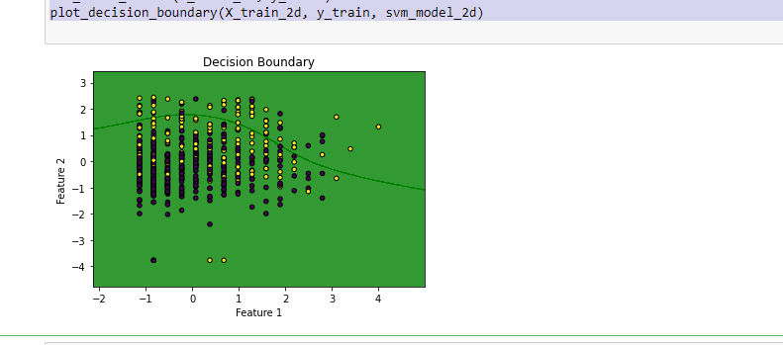import

matplotlib.pyplot as plt

import seaborn as sns

from sklearn.metrics import confusion_matrix, classification_report

conf_matrix = confusion_matrix(y_test, y_pred)

plt.figure(figsize=(8, 6))

sns.heatmap(conf_matrix, annot=True, fmt='d', cmap='Greys') # Change 'Oranges' to your desired color palette

plt.xlabel('Predicted Labels')

plt.ylabel('True Labels')

plt.title('Confusion Matrix')

plt.show()

**OUTPUT:**

**Task No. 02**: Design the workflow with the help of KNIME to implement the Support Vector

Machine Algorithm on any classification dataset.

**Solution:**

**Output:**

